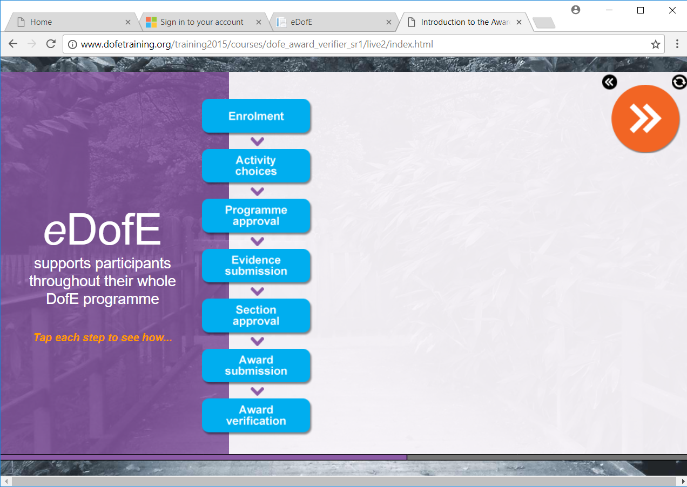

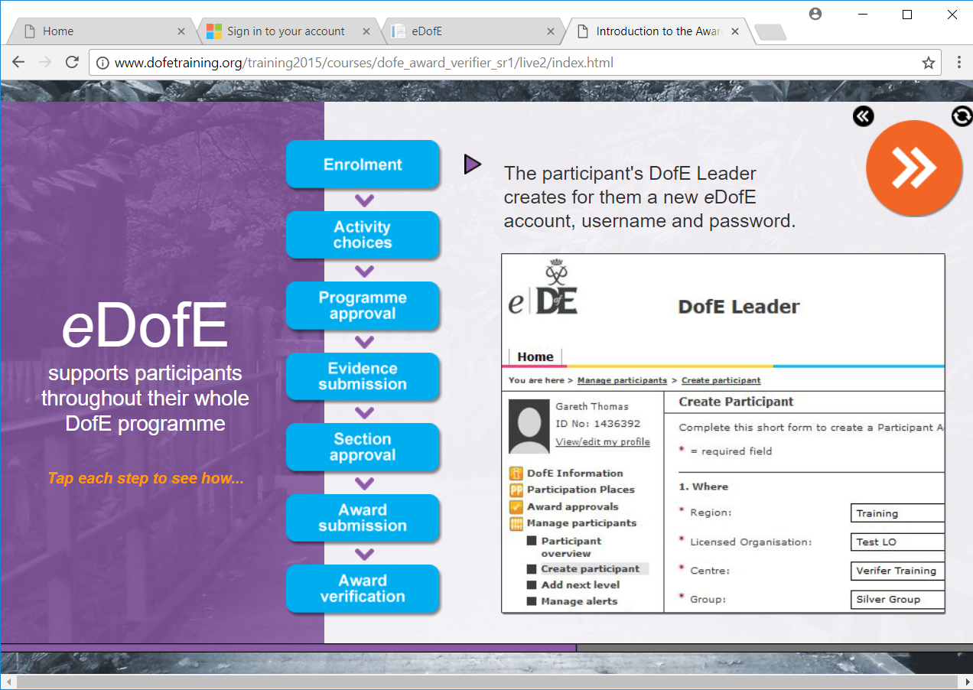

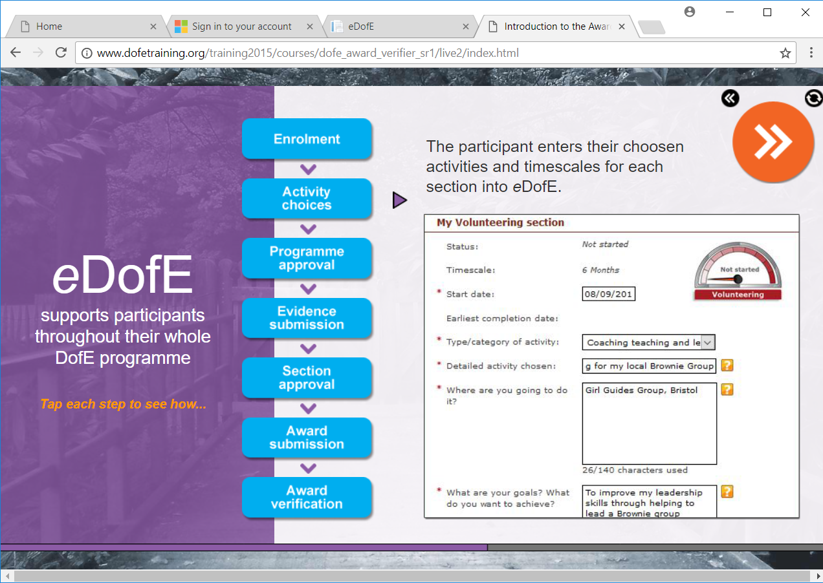
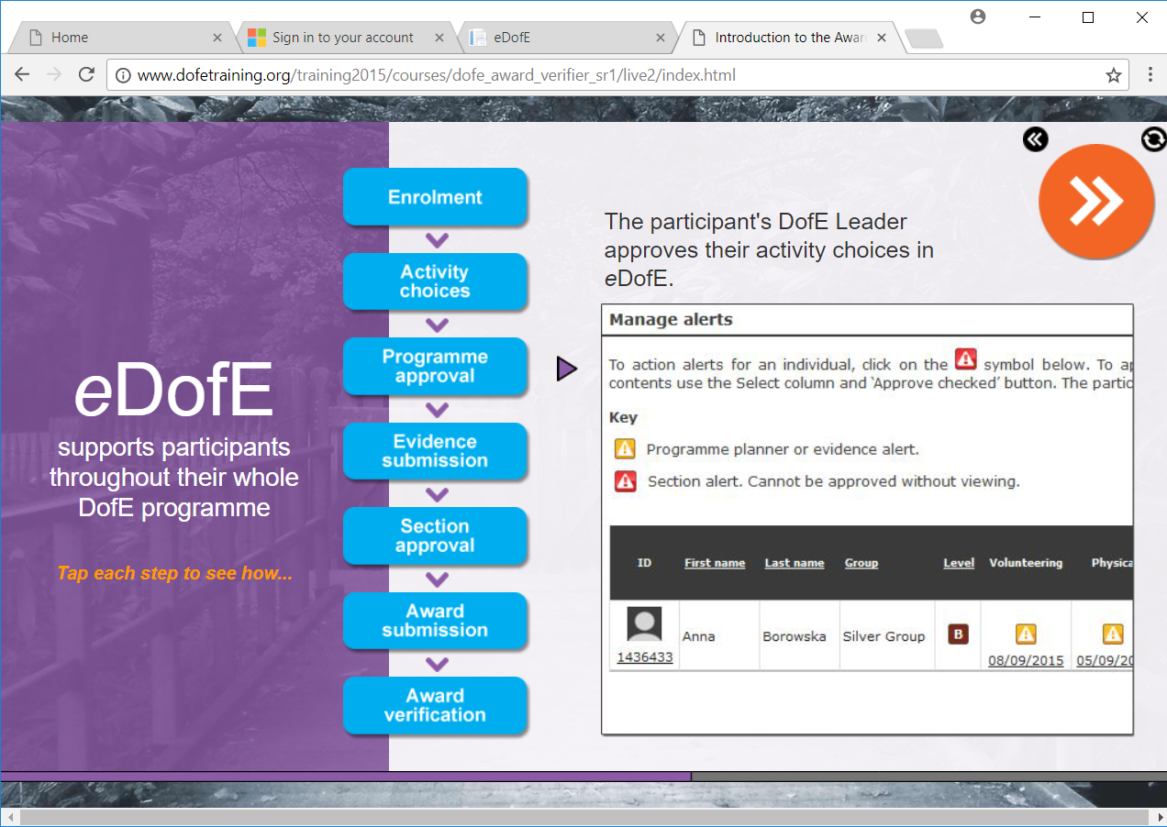

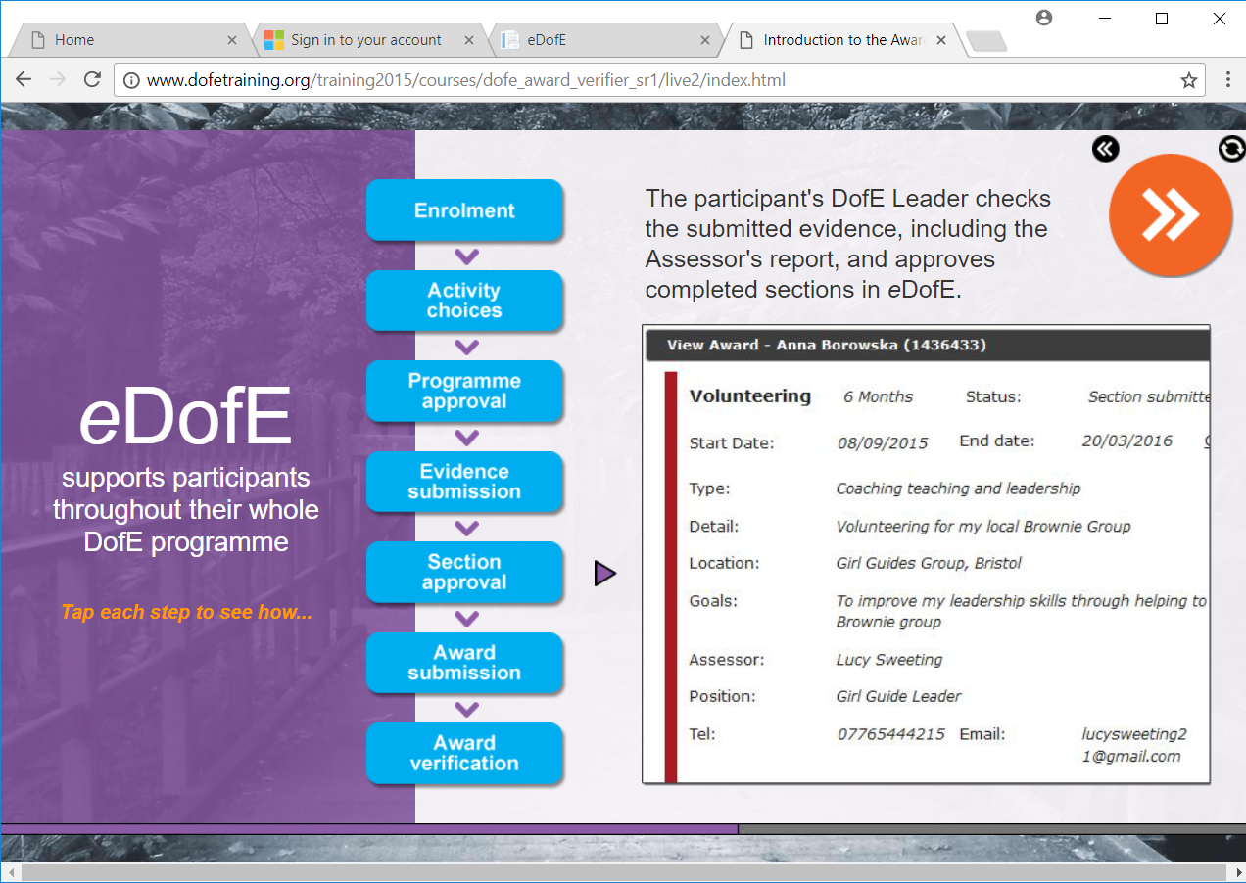

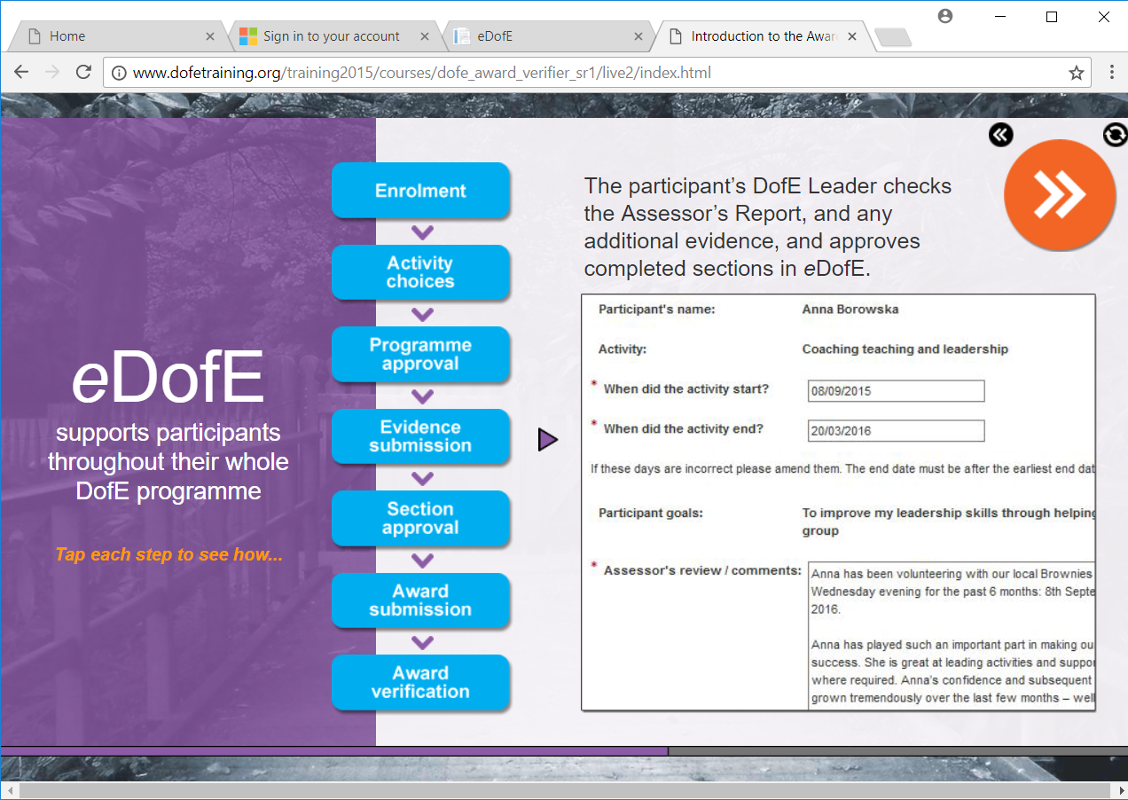
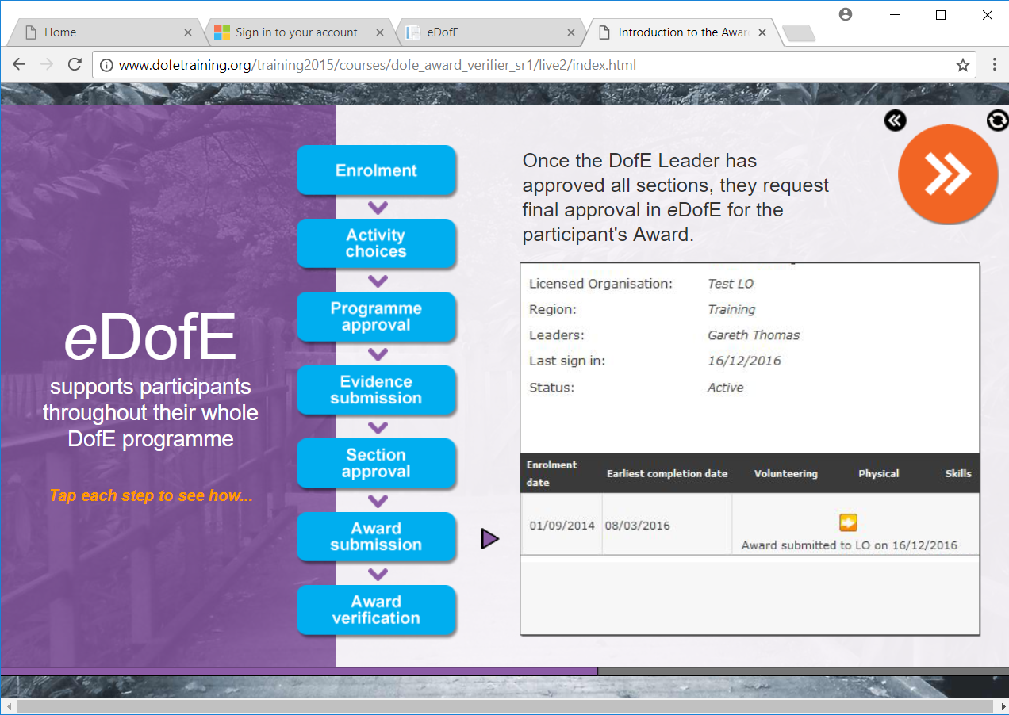

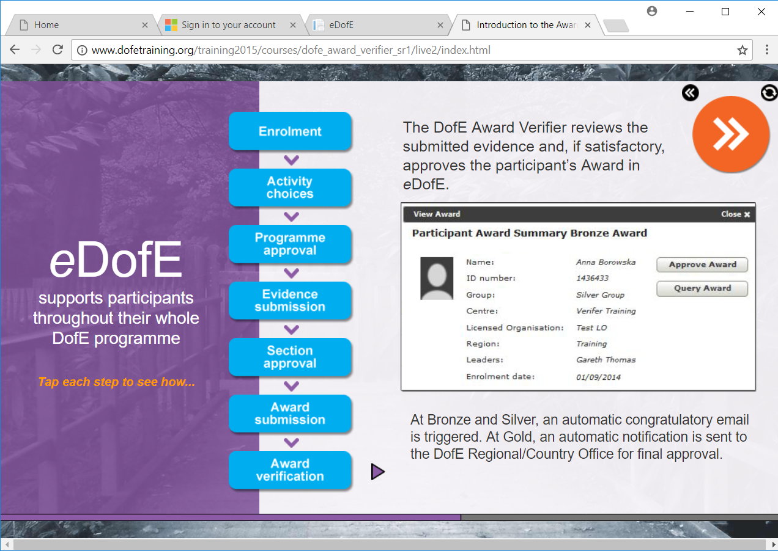

Once approved, Certificates are produced in the DofE Awards Office for Bronze & Silver Participants. Gold Certificates are sent from DofE Edinburgh Office.

Duke of Edinburgh Leaders – Aberdeenshire Council
A Group Leader will have up to 7 participants in any Group (Participants should name their Group to give ownership)

The Leader of that Group should be those participants ‘go to’ for information.
The Group Leader will arrange DofE Sessions/meetings to ensure participants are keeping on track.
The Group Leader will ensure eDofE is updated and appropriate for each participant, queries should be directed to the Centre Coordinator, then if still unsure the DofE Awards Team.
The Group Leader will provide or organise with the Coordinator all training required for their Expeditions. (This can be shared with other Leaders)
It is suggested that a register is kept for these training sessions and that missed sessions are ‘caught up’ by the participants.
The Leader should approve/query any evidence giving via eDofE, ideally within 10 days.
Leaders should check their DofE Account on a regular basis as this is one of the means of communication for participants/Awards Office/DofE.

